Installation Instructions
You can install the android build using 2 methods.
1) Direct .apk file Installation by copying it to phone internal storage.(Simplest Way)
Step 1: Go to https://github.com/antonyphp/weather-station-model/tree/master/Builds
step 2 : Right click on "weather-station.apk" and select "save link as". Save it in any Computer location.
Step 3 : Copy "weather-station.apk" to Android Phone storage.
step 4 : Open "weather-station.apk" from Android phone using any File explorer application(eg:EsFile Explorer).
step 5 : Tap on Install and follow install instrctions.

2)Clone Android Project from GitHub to Android Studio
Step 1: Use Git Gui window application(or source tree for mac & linux) to clone github project to local machine.
Step 2 : Provide source location as https://github.com/antonyphp/weather-station-model/tree/master/WeatherForecast and destination as any location in local machine.
step 3 : Open Android studio File > Open then locate to clone destination path and open project.
step 4 : Connect an android phone to the computer(make sure that it is detected by Android Studio)
Step 4 : Once the project is opened completely in Android studio, select Run > Run 'app'. The project will be installed on the phone and will be opened.

Application Usage And Testing
For testing the application just open the application in Android Phone. You can see following main screen
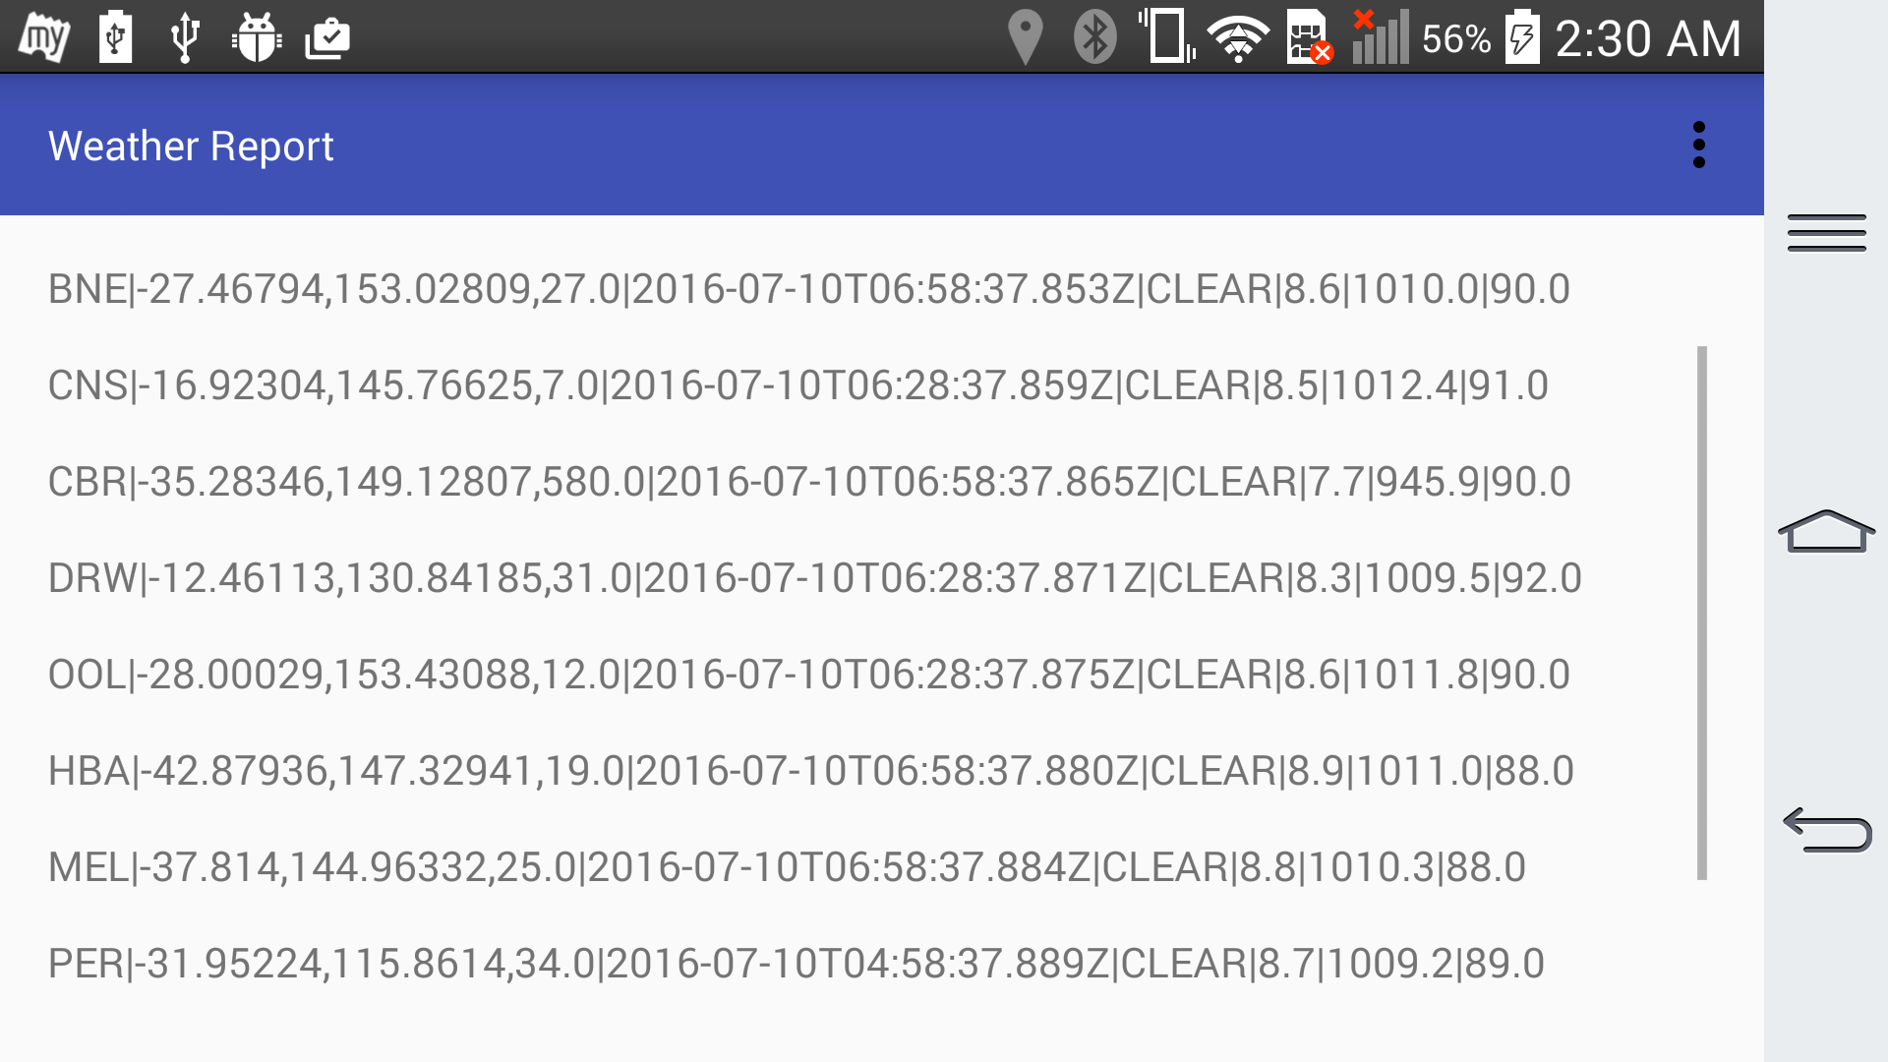
You can see weather report for any future date or past date. For testing the same, just advance date and time in your android phone from settings > General > Date & Time >Set Date/ Set Time. Once you change the date and time return back to our application to see the weather report change. If the screen is not updated,tap on tool bar options menu button(3 vertical dots on upper right hand side) to get the refresh button.

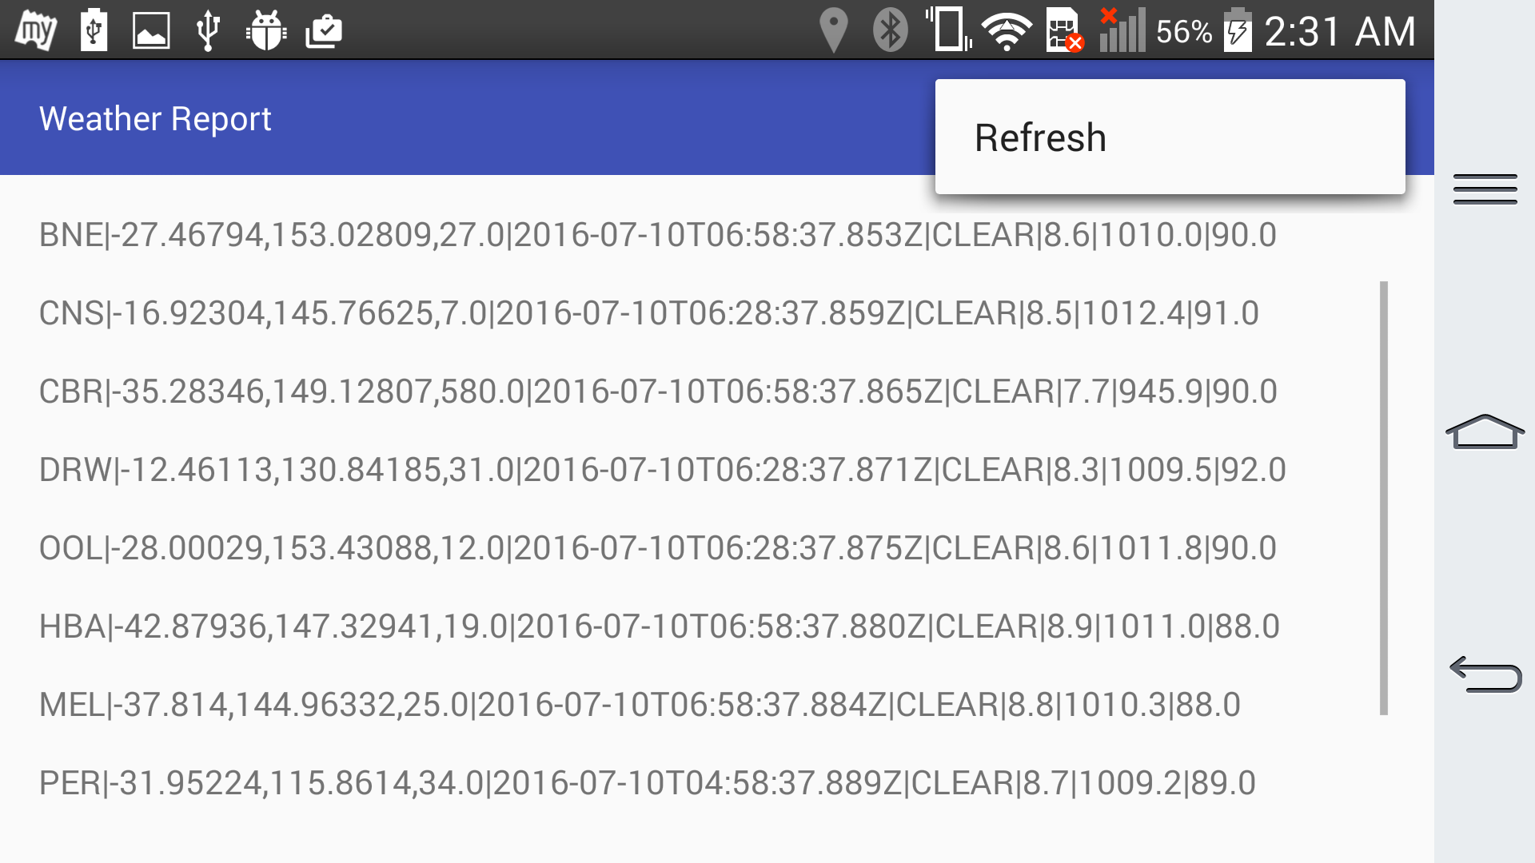
On tapping Refresh button, the result will be get updated.

